Summary Table – Univariate Genmod Analysis

Macro Name: UNI_GENMOD
Created Date/Author: May 14, 2013/Dana Nickleach
Last Update Date/Person: May 7, 2014/Dana Nickleach
Current Version: V7
Working Environment: SAS 9.3 English version

Contact: Dr. Yuan Liu yliu31@emory.edu

Purpose: To conduct univariate regression analysis for each variable in the dataset using a GEE model via PROC GENMOD. A non-GEE model can also be used. The normal, binomial, Poisson, or negative binomial distributions can be used. An identity link will be used with a normal distribution, a logit link with binomial, and a log link with Poisson or negative binomial. The parameter estimates with 95% CI, p-value, and type III p-values are resented. For categorical variables, the reference group will be shown along with the number of observation in each category.

Notes:

Parameters:

Macro variable | Description
DSN | The name of the data set to be analyzed.
OUTCOME | The name of the continuous or binary outcome variable.
DESC | Set to T to reverse the order of a binary outcome (optional). The default value is F.
CLIST | List of categorical variables, separated by empty space.
CREFLIST | If you want to change the reference groups of the categorical variables then repeat CLIST here and follow each variable name by the (desc) option, where needed. Separate variable terms with an asterisk instead of a space (optional).
NLIST | List of numerical variables, separated by empty space.
DIST | Probability distribution to use for the model (optional). Valid values are NORMAL, BINOMIAL, POISSON, and NEGBIN. The default value is NORMAL.
SUBJECT | Subject-effect to be specified in REPEATED statement in order to use a GEE model. Leave blank if not using a GEE model.
WITHINSUB | Within-subject-effect to be specified in REPEATED statement. This is optional if using a GEE model. Leave blank if not using a GEE model.
TYPE | Correlation structure keyword to be specified in REPEATED statement. This needs to be specified if SUBJECT is specified. Leave blank if not using a GEE model.
TYPE3 | Set to F to suppress type III p-values from being reported in the table (optional). The default value is T.
OUTPATH | Path for output table to be stored.
FNAME | File name for output table.
DEBUG | Set to T if running in debug mode (optional). Work datasets will not be deleted in debug mode. This is useful if you are editing the code or want to further manipulate the resulting data sets. The default value is F.

Usage Example:

DATA analysis;
input group id os_censor Sex $ Age duration os progress $ trt $;
LABEL os = 'Overall Survival (months)'
progress = 'Progression'
trt = 'Treatment'
duration = 'Duration of Radiation';
DATALINES;
1 1 1 M 40 44 20 No B
1 2 1 F 45 46 16 Yes A
1 3 1 F 40 32 20 No B
1 4 1 F 47 32 23 No B
2 5 0 M 41 25 22 No B
2 6 1 M 54 35 13 No B
2 7 1 M 48 50 9 Yes A
3 8 1 M 36 33 12 Yes B
3 9 0 F 49 51 8 Yes A
3 10 1 M 49 52 10 Yes A
4 11 1 M 44 35 12 No A
4 12 1 M 49 50 8 Yes A
4 13 1 M 44 44 14 Yes A
4 14 1 M 50 31 10 Yes A
5 15 1 M 53 40 15 No B
5 16 0 M 52 29 20 Yes B
6 17 1 F 46 45 5 Yes A
6 18 1 F 37 44 11 Yes A
6 19 1 M 49 46 13 No B
6 20 1 M 42 31 11 No A
;

TITLE 'Table 2 Univariate Association with Duration';
%UNI_GENMOD(DSN=analysis,
OUTCOME=duration,
CLIST=trt sex,
NLIST=age,
SUBJECT=group,
TYPE=EXCH,
TYPE3=T,
OUTPATH=C:\Documents and Settings\User\My Documents\,
FNAME=Table 2 Univariate Association with Duration);
TITLE;

Summary Table Example:

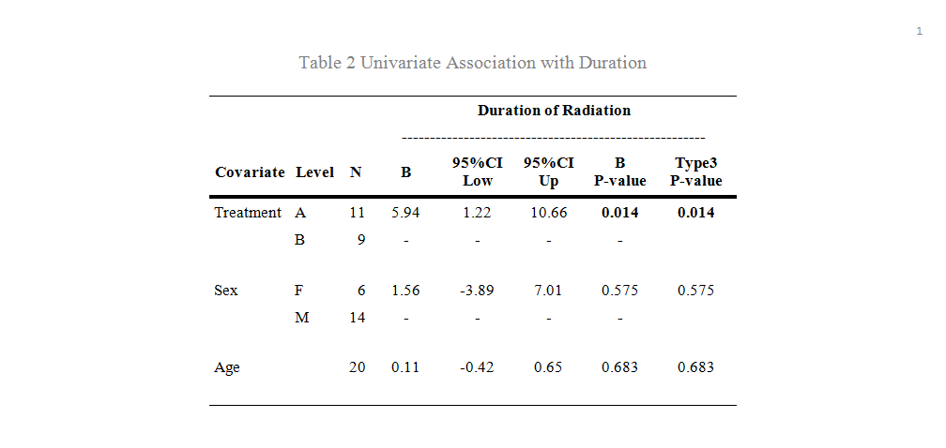

Permission:

Permission is hereby granted, free of charge, to any person obtaining a copy of this software and associated documentation files (the "Software"), to deal in the Software without restriction, including without limitation the rights to use, copy, modify, merge, publish, distribute, sublicense, and/or sell copies of the Software, and to permit persons to whom the Software is furnished to do so, subject to the following conditions:
The above copyright notice and this permission notice shall be included in all copies or substantial portions of the Software.
THE SOFTWARE IS PROVIDED "AS IS", WITHOUT WARRANTY OF ANY KIND, EXPRESS OR IMPLIED, INCLUDING BUT NOT LIMITED TO THE WARRANTIES OF MERCHANTABILITY, FITNESS FOR A PARTICULAR PURPOSE AND NONINFRINGEMENT. IN NO EVENT SHALL THE AUTHORS OR COPYRIGHT HOLDERS BE LIABLE FOR ANY CLAIM, DAMAGES OR OTHER LIABILITY, WHETHER IN AN ACTION OF CONTRACT, TORT OR OTHERWISE, ARISING FROM, OUT OF OR IN CONNECTION WITH THE SOFTWARE OR THE USE OR OTHER DEALINGS IN THE SOFTWARE.

Log of Updates:

Date | By | Description | Version
5/21/13 | Dana Nickleach (dnickle@emory.edu) | Modified so that it will also run non-GEE models and added DIST parameter. | V2
5/28/13 | Dana Nickleach (dnickle@emory.edu) | Fixed ordering issue. | V3
11/8/13 | Dana Nickleach (dnickle@emory.edu) | Added BINOMIAL as a distribution option and added the DESC parameter. | V4
12/14/13 | Dana Nickleach (dnickle@emory.edu) | Added WITHINSUB parameter, added error check for missing parameters, and adjusted so that variable names can be 32 characters. | V5
2/11/14 | Dana Nickleach (dnickle@emory.edu) | Added CREFLIST parameter. | V6
5/7/14 | Dana Nickleach (dnickle@emory.edu) | Collapsed estimate and CI into one column. | V7

